**Activity 13.1 Mohammed Abdin**

**Submission Instructions:**

Your submission for this assignment should be a Word document that includes the following screenshots, each labeled for the step that the screenshot represents:

1. Provide a screenshot of the container.py file in VS Code.

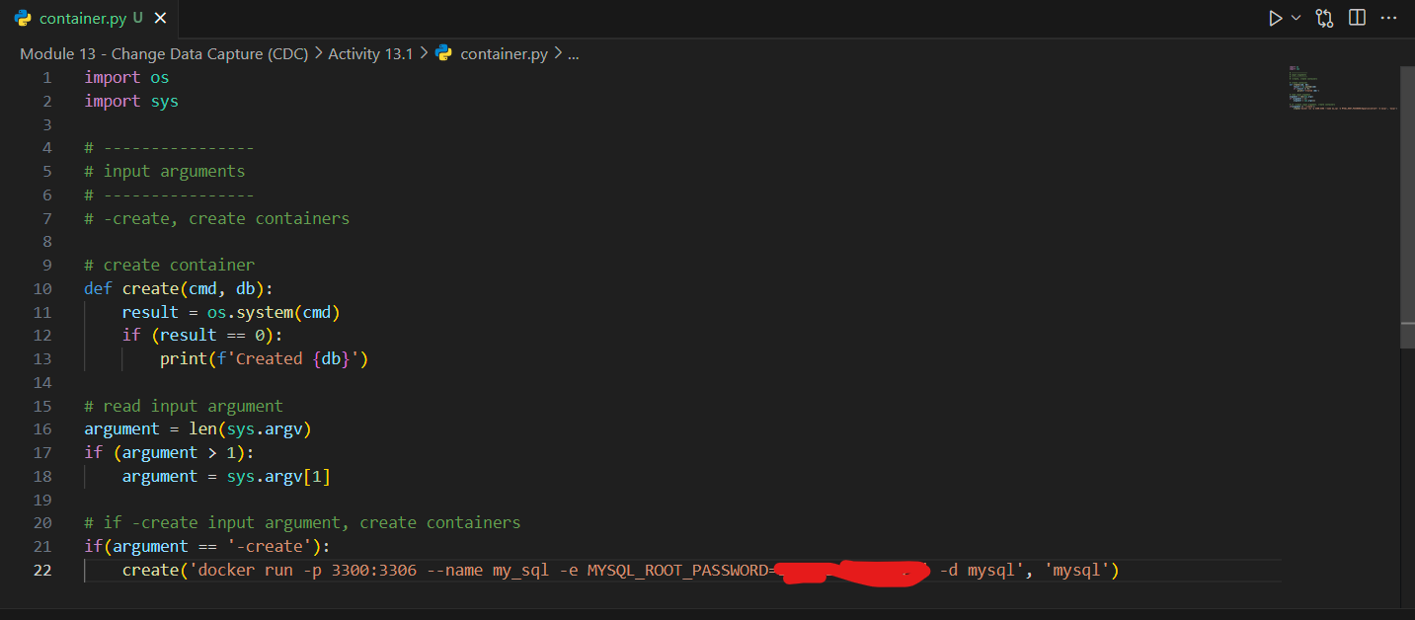

1. Provide a screenshot that shows you have run the container.py file from the Terminal window and passed the -create argument as a parameter.

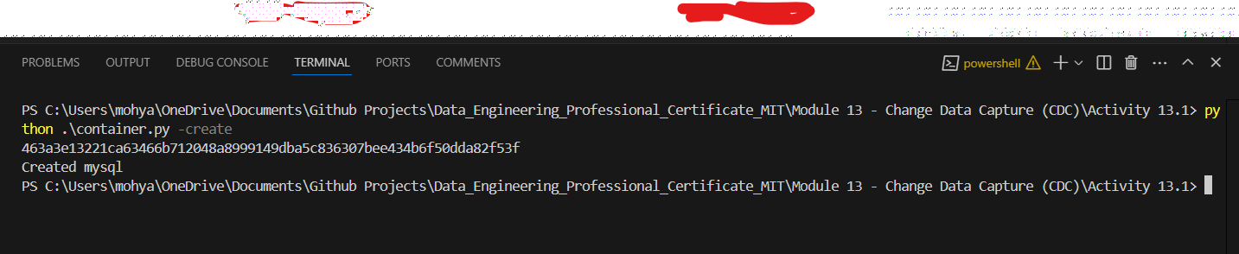

1. Provide a screenshot of your Docker desktop that shows MySQL running.

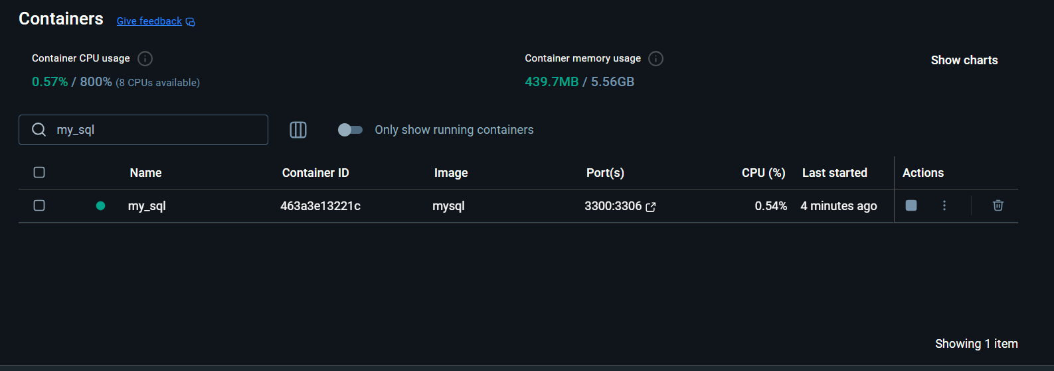

1. Provide a screenshot of the command prompt output when you run the code to delete the MySQL *container* and run the containers.py Python program from the Terminal window by passing -delete as a parameter.

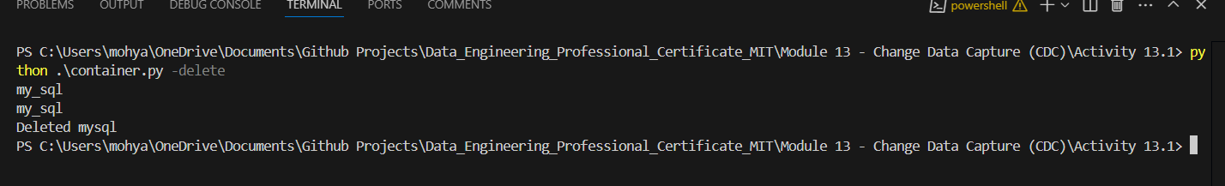

1. Provide a screenshot of your Docker desktop to show that the MySQL *container* has been deleted.

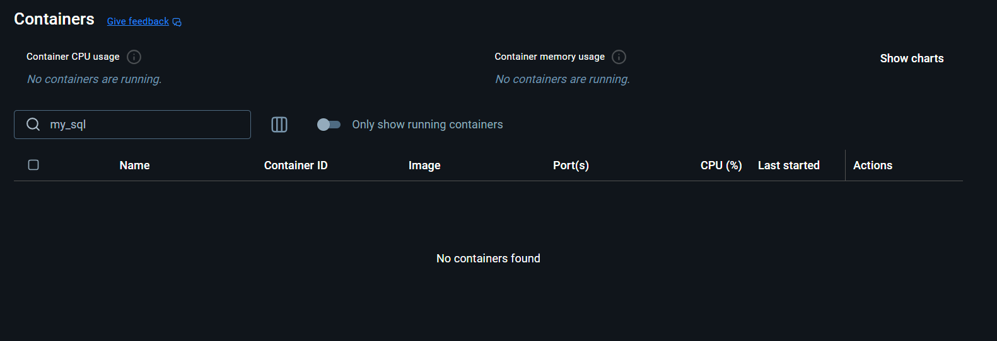

1. Provide a screenshot to show that you have included the code to create the other database *containers* in MongoDB, Redis, and Cassandra.

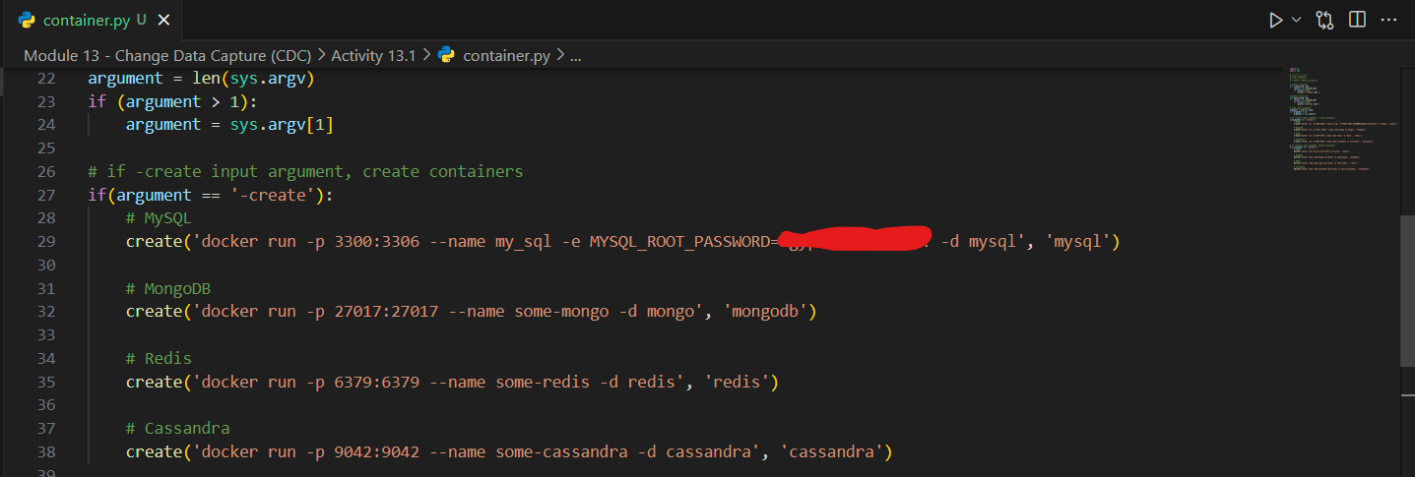

1. Provide a screenshot of the command prompt output to show that you have run the containers.py Python program from the Terminal window passing -create as a parameter.

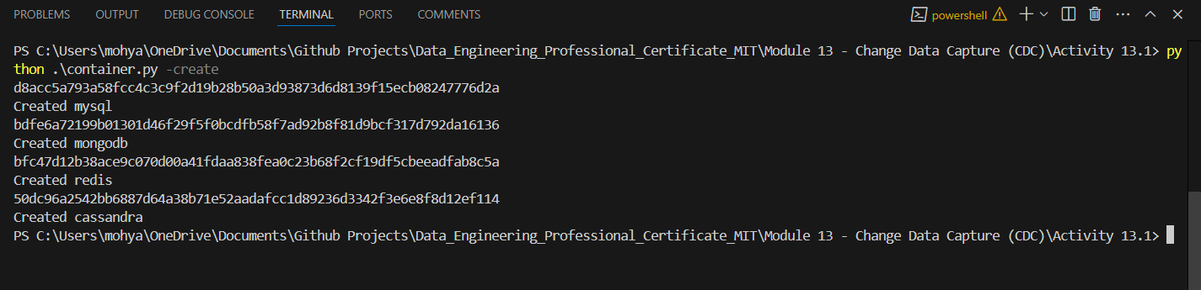

1. Provide a screenshot of your Docker desktop showing that the four database *containers* are running.

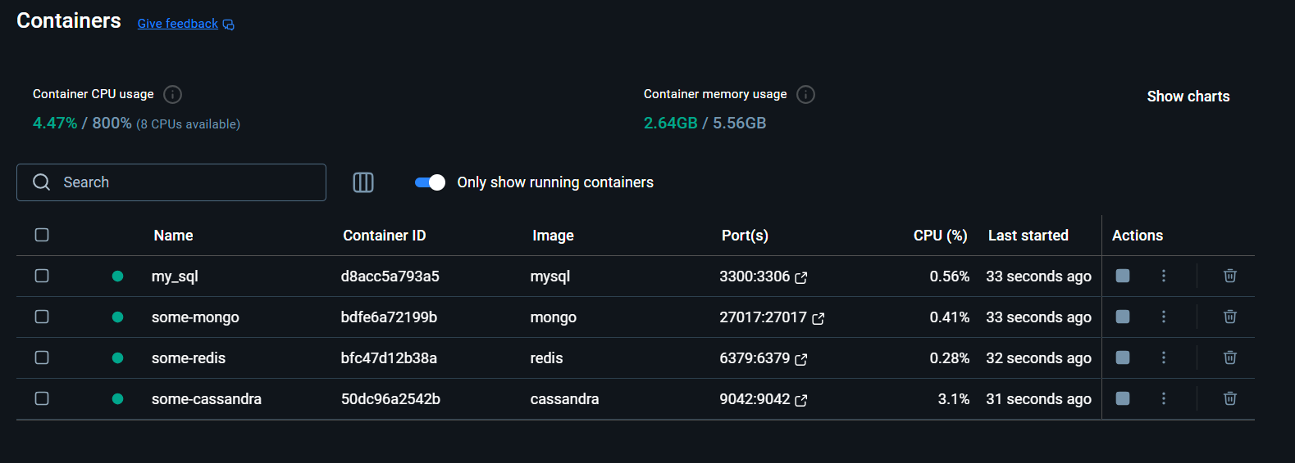

1. Provide a screenshot of VS Code after including the code to delete the three database *containers* for MongoDB, Redis, and Cassandra to show that you added the calls to delete these three databases.

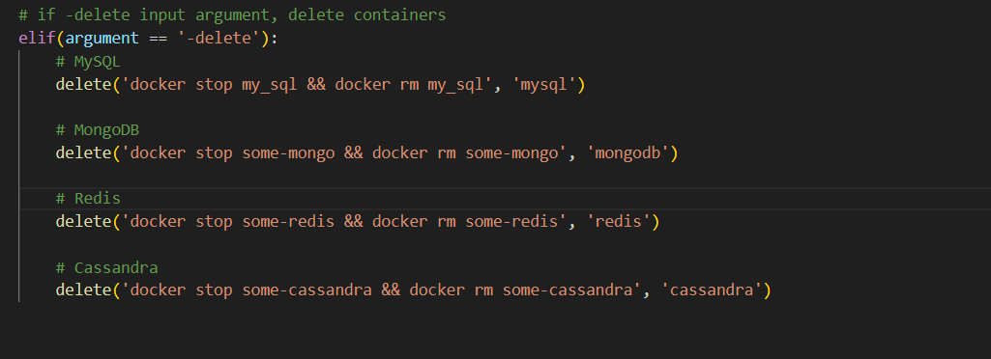

1. Provide a screenshot of the command prompt output to show that you have successfully run the containers.py Python program from the Terminal window passing -delete as a parameter.

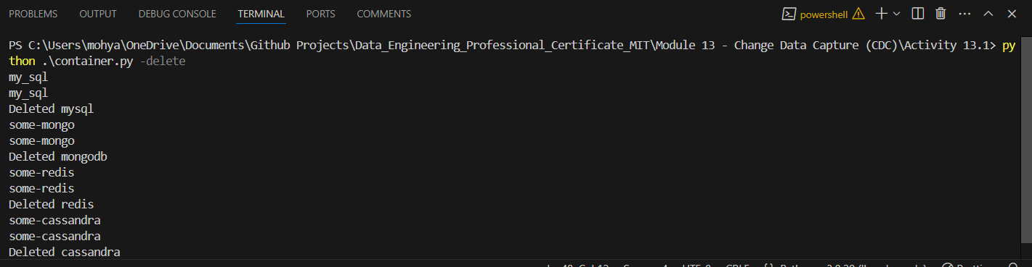

1. Provide a screenshot of your Docker desktop showing that all the database *containers* have been deleted.

